**Assignment 1: Python Worm**

Group Members: Wayne Lin (solo)

**Installation Instructions:**

**Note: This worm runs only in Python 3.9 and was tested using Kali Linux VMs.**

Tested Python versions: *3.9.2, 3.9.7, 3.9.9*

**EC1 and EC2:** both implemented

I was not able to get Lubuntux86 to boot, not even a freshly download standalone instance in VirtualBox. The boot screen always shows an error and freezes indefinitely. This worm should run correctly in Lubuntux86 as long as all required packages are installed, the network adapter’s name format is “eth0” instead of “enp0s3” and the user **sets the attacking host’s IPv4 address to 10.0.0.10 (either through dynamic DHCP reservation in router R1’s configuration, or via spoofing the MAC address)**, but I have no way to confirm. R1’s setup is explained later.

Instructions using the provided Kali Linux image from the Google Drive shared folder are detailed below.

**Prior to adding the Kali Linux template to GNS3:**

1. Import Kali Linux into VirtualBox
2. Go to Settings for the newly added Kali VM
3. Make sure two network adapters are enabled and setup properly:
4. Enable the second network adapter
5. Set the first adapter to “Not attached”
6. Set the second adapter to either “NAT” or “Bridged” (see Figure 1)

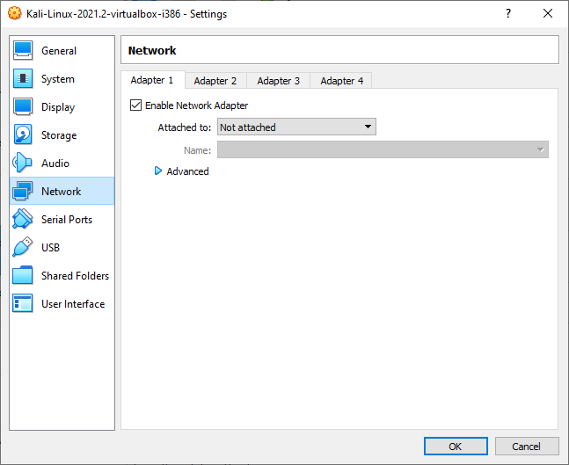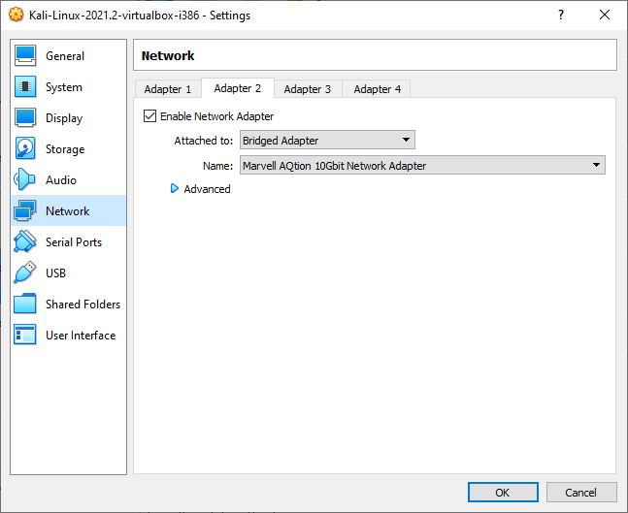

**Figure 1) Kali VirtualBox settings**

1. Start Kali through VirtualBox
2. Open a terminal session and install required packages (when prompted, select ‘y’ / yes):
3. Make sure Python 3.9 is installed:
4. **sudo apt** install **-y** **python3.9** **--upgrade**
5. Ensure that network adapter 2 is enabled and Kali is connected to the internet
6. **sudo apt** update **&&** **sudo apt** install -y python3-pip
7. **sudo pip3** install **--upgrade** pip
8. **sudo** -H **pip3** install **nmap** **--ignore-installed**
9. **sudo** -H **pip3** install **netinfo** **--ignore-installed**
10. **sudo** -H **pip3** install **netifaces** **--ignore-installed**
11. **python3** **--version** (verify the installed Python3 version is *3.9.X*)
12. **pip3** list (verify all required packages are present)
13. Now we need to install the ssh server and modify the ssh configuration file to allow root logins. First, we must change file user permissions to allow editing.
14. **sudo apt** install **openssh-server**
15. **sudo chmod 0777** */etc/ssh/sshd_config*
16. **mousepad** */etc/ssh/sshd_config*
17. Go to the following line and modify it as shown below (be sure to delete the ‘#’):
18. #PermitRootLogin prohibit-password 🡪 PermitRootLogin **yes**
19. Save the file (see Figures 3.1-3.4)

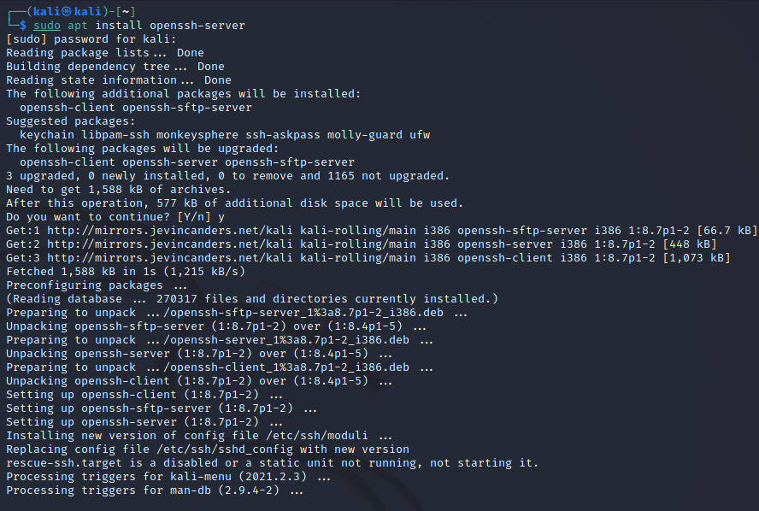

**Figure 3.1) Installation of *openssh-server***

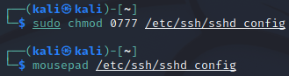

**Figure 3.2) Modifying file permissions and opening SSH configuration for editing**

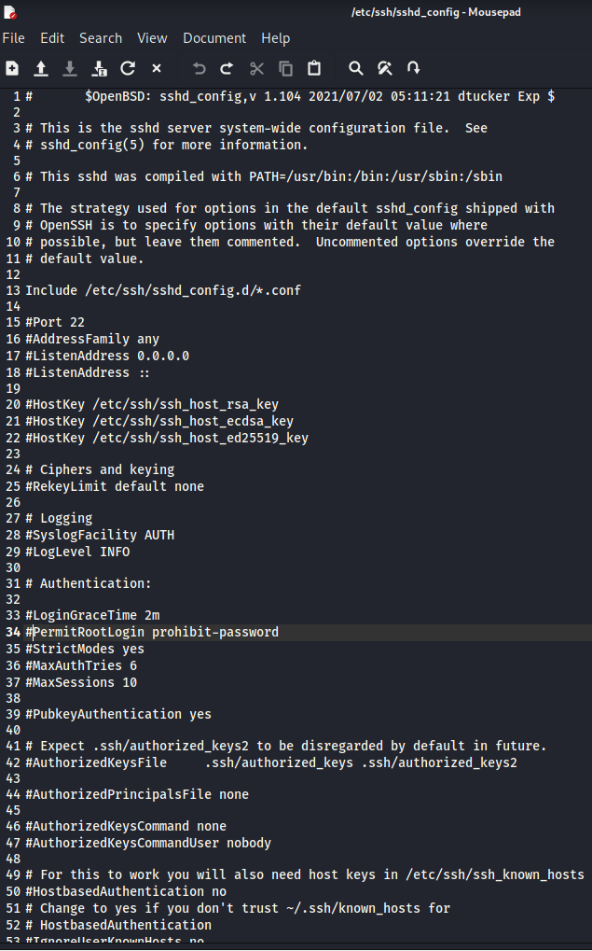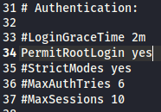

**Figures 3.3 and 3.4) Enabling root login in *sshd_config***

1. Next, we need to enable and run the ssh service which is currently stopped:
2. **sudo systemctl** **enable** ssh.service
3. **sudo systemctl** **start** ssh.service
4. **sudo systemctl** **status** ssh.service (verify that ssh is running)

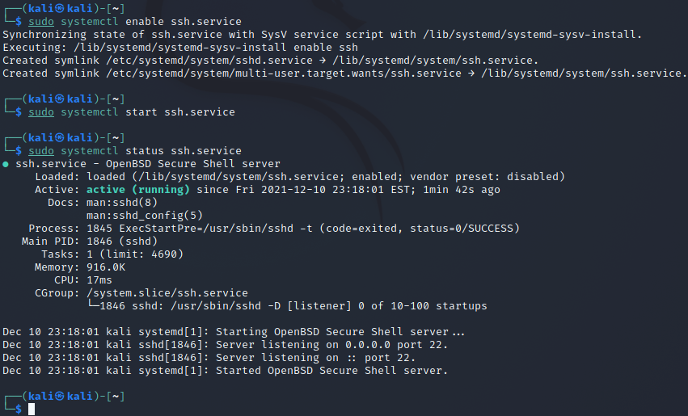

**Figure 4) Command sequence to enable and start the SSH server**

1. (*Optional, QOL*) Change Kali power settings to prevent idle timeout:
2. Under power manager - Display tab, max out the display power management to blank after 60 minutes.
3. Under power manager - Security tab, change to never automatically lock the session and also uncheck “lock screen when system is going to sleep”.

**Now we are ready to add our Kali VM template to GNS3.**

**Important steps when importing:**

1. Under general settings, make sure to check (enable) “Use as a linked-base VM (experimental)”.
2. In the Network tab, make sure the number of adapters is 2, change the name format to “eth{0)”.
3. (Recommended, troubleshooting) check “Allow GNS3 to use any configured VirtualBox adapter”.

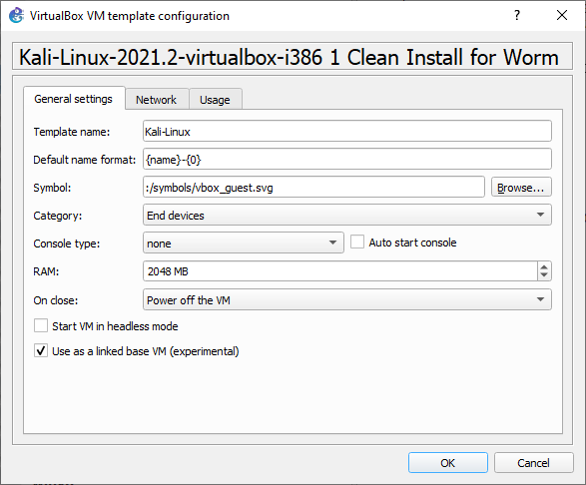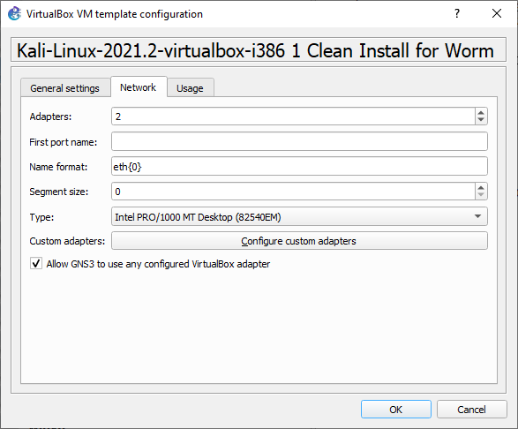

**Figure 5) Kali Linux VM template settings in GNS3**

**Construct the GNS3 topology as shown below:**

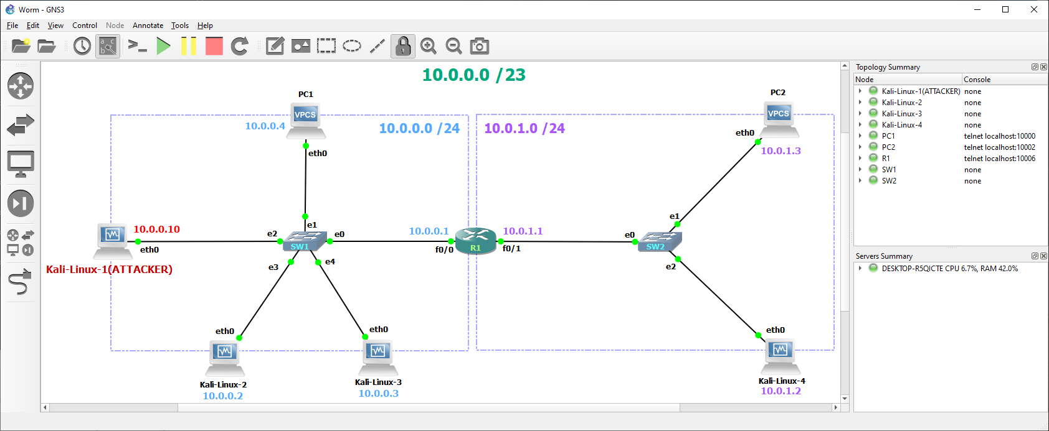

**Figure 6) GNS3 Final Topology including EC2 implementation**

**VPCS configurations (see Figure 7):**

We need to delay the VPCS machines’ router DHCP assignments until after our Kali VMs have received their final IPv4 address assignments.

1) Edit the startup config for PC1 and PC2 and add the following lines after “set pcname PC[X]”:

sleep [30] [waiting for DHCP server to initialize...press ENTER key after 30 seconds]

dhcp

2) “Configure” PC1 and PC2 and check “Auto start console”

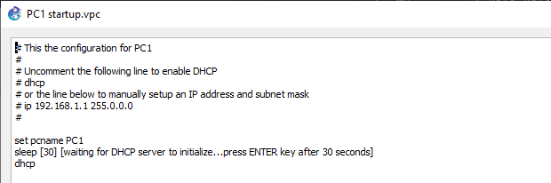

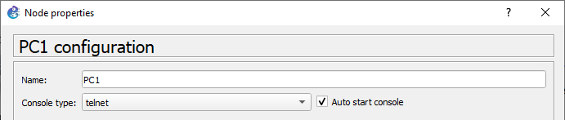

**Figure 7) VPCS Configuration**

**Designate an attack machine:**

1. Make sure Kali-Linux-1 is connected to Switch 1. Start only Kali-Linux-1.
2. Get this machine’s MAC address by entering in terminal: **ifconfig** eth0
3. Copy the 12-bit block after “ether” into a local text editor - in the figure below, my attack machine has a MAC address of 08:00:27:d4:ef:23
4. After this step shutdown the Kali node.

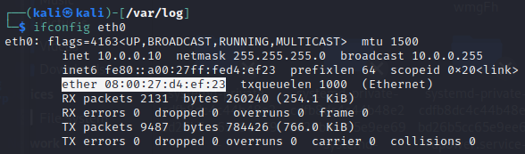

**Figure 8) Save the Kali attacker’s MAC address**

**Router Configuration**

Next, it is time to setup R1.

Configure the node properties such that the “Auto start console” is checked, and there are two filled adapter slots as shown below.

You can also paste the contents of *R1_i1_startup-config.cfg* into R1’s config, but you need to match the MAC address of the dynamic reservation to that of the attacking VM (explained on the next 2 pages).

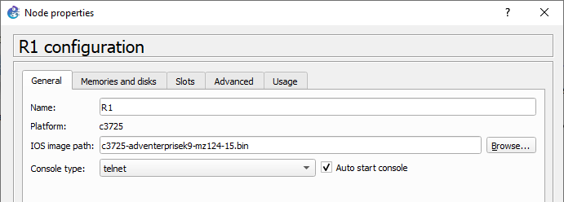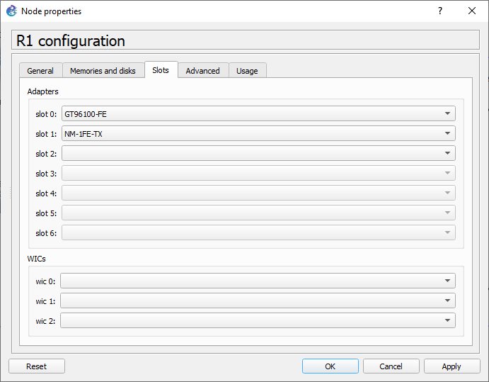**Figure 9.1) R1 Node Configuration**

**Start R1 by itself and edit the startup configuration as follows:**

**R1#**conf t

**R1(config)#**int f0/0

**R1(config-if)#**ip add 10.0.0.1 255.255.255.0

**R1(config-if)#**no shut

**R1(config-if)#**int f0/1

**R1(config-if)#**ip add 10.0.1.1 255.255.255.0

**R1(config-if)#**no shut

**R1(config-if)#**do sh ip int br

Interface IP-Address OK? Method Status Protocol

FastEthernet0/0 10.0.0.1 YES *manual up up*

FastEthernet0/1 10.0.1.1 YES *manual up up*

FastEthernet1/0 unassigned YES *manual administratively down down*

**R1(config-if)#**exit

**R1(config)#**do wr

Building configuration…

[OK]

**// Configure DHCP Servers**

**// Configure the “Blue” network**

**R1#**conf t

**R1(config)#**service dhcp

**R1(config)#**ip dhcp pool BLUE

**// I named this pool NET, but BLUE is more informative given the color settings in the GNS3 topology**

**R1(dhcp-config)#**network 10.0.0.0 255.255.255.0

**R1(dhcp-config)#**default-router 10.0.0.1

**R1(dhcp-config)#**dns-server 10.0.0.1

**R1(dhcp-config)#**lease 7 0 0

**R1(dhcp-config)#**ip dhcp excluded-address 10.0.0.1

**R1(dhcp-config)#**exit

**R1(config)#**do wr

**// Dynamic reservation for our attacker**

**R1(config)#**ip dhcp pool ATP

**// For Lubuntux86 use “hardware-address”**

**// simply remove all colons and separate groups of 4 by a period. // 08:00:27:d4:ef:23 🡪 0800.27d4.ef23**

**R1(dhcp-config)#**hardware-address <attacker’s formatted MAC address>

**// For Kali use “client-identifier” and offset the MAC address // with two extra left bits "01”.**

**// Also remove colons and separate each 4 characters by a period**

**( i.e.: 08:00:27:d4:ef:23 🡪 0108.0027.d4ef.23) :**

**R1(dhcp-config)#**client-identifier <attacker’s formatted MAC address>

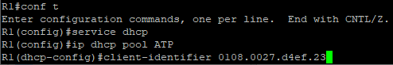

**Figure 9) Example of dynamic reservation by MAC address in Kali**

**// Set the attacker to the IPv4 address hard-coded in worm.py**

**// This way the program knows to remove the attacker from the**

**// list of victims and the attacker will not be infected**

**R1(dhcp-config)#**host 10.0.0.10 255.255.255.0

**R1(dhcp-config)#**default-router 10.0.0.1

**R1(dhcp-config)#**dns-server 10.0.0.1

**R1(dhcp-config)#**exit

**R1(config)#**do wr

**// Configure the “Purple” network**

**R1(config)#**ip dhcp pool PURP

**R1(dhcp-config)#**network 10.0.1.0 255.255.255.0

**R1(dhcp-config)#**default-router 10.0.1.1

**R1(dhcp-config)#**lease 3 0 0

**R1(dhcp-config)#**ip dhcp excluded-address 10.0.1.1

**R1(dhcp-config)#**exit

**R1(config)#**do wr

Next, start R1 and the designated Kali/Lubuntux86 attack VM. In terminal, enter: **ifconfig** eth0.

Make sure that the IPv4 address has been set to the router’s dynamic reservation (**10.0.0.10**).

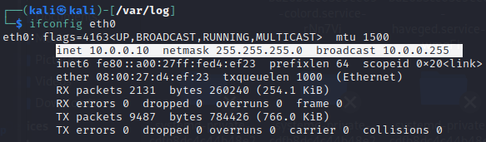

**Figure 10) Attacking VM must be assigned the IPv4 address 10.0.0.10**

Create a new file on the attacker’s Desktop and copy the contents of *worm.py*. Save the file as *worm.py*.

Enter the terminal commands:

**cd** Desktop

**cp** *worm.py /tmp/worm.py*

**Now we can start all devices together in the GNS3 Topology.**

First, do not yet trigger PC1 and PC2 to acquire a DHCP address. Log into the Kali/Lubuntu86 victim VMs and check the network settings. Make sure adapter 1 is set to the “Generic Driver”, and that the active connection is set to this adapter.

In terminal, enter: **ifconfig** eth0

Confirm eth0 is active and properly configured on all three Kali/Lubuntu victim VMs by checking that inet and inet6 are both present.

Their IPv4 addresses should be **10.0.0.2**, **10.0.0.3** (victims in the same network as attacker) and **10.0.1.2** (victim on the adjacent network).

Make sure **10.0.0.4** and **10.0.1.3** are not assigned to any of the Kali/Lubuntu VMs! These are reserved for the VPCS machines (hard-coded in *worm.py* because trying to attack VPCS is incredibly slow and unproductive).

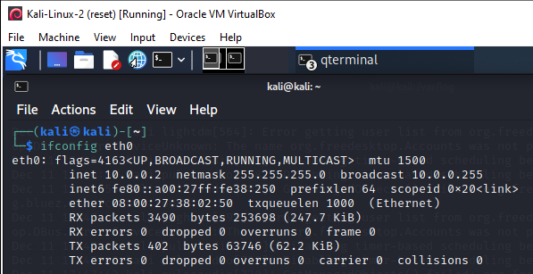

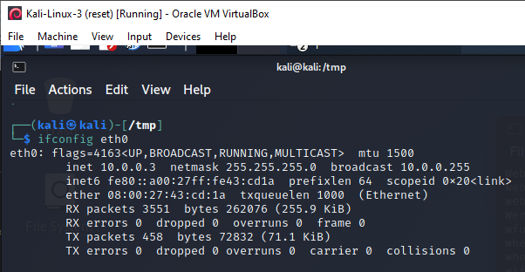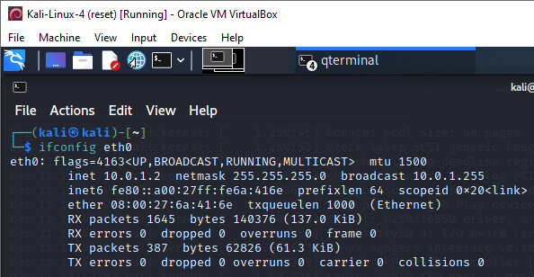

**Figures 11) IP address assignments for the victim VMs**

Finally, press [Enter] on the VPCS devices **PC1** and **PC2**. They will request a DHCP address and *should* be assigned **10.0.0.4** and **10.0.1.3**, respectively. If their IPv4 addresses were somehow set to something else, open the config file, remove the “dhcp” line and manually assign them these static IPv4 addresses. If this happens you will need to restart all devices.

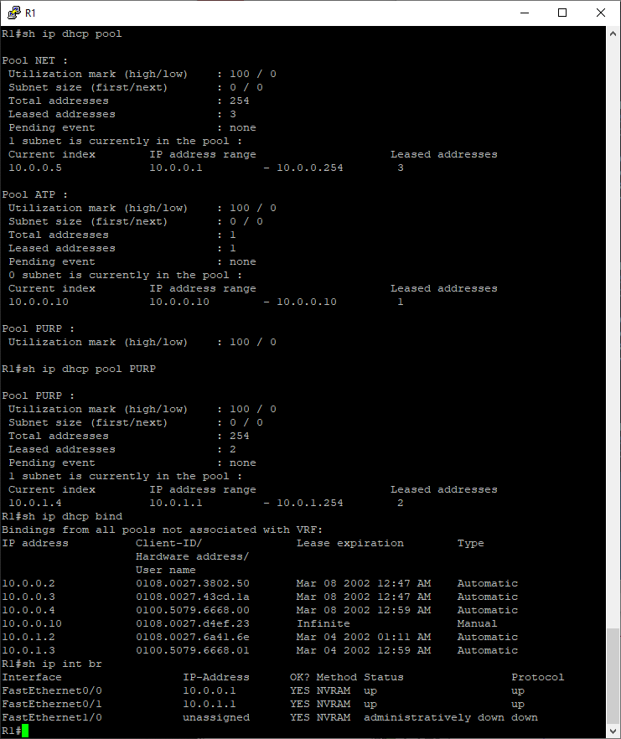

**Figure 12.2) The final R1 DHCP bindings should look like this**

We can finally begin our worm infection. In the attacker VM, make sure *worm.py* exists on the Desktop and in /tmp/. If the /tmp/ file is ever deleted, restore it by copying it back from the Desktop.

/////////////////////////////

**cd** Desktop

**cp** *worm.py /tmp/worm.py*

/////////////////////////////

List of commands:

**python3** worm.py **(default)** Attacks victims on the same network, also tries to attack R1

**python3** worm.py **-m** or **--multi** **(EC1)**, Infect victim(s) on the adjacent network as well

**python3** worm.py **-c** or **--clean** **(EC2)**, Disinfect all victims, run it after infecting machines.

**python3** worm.py **-v** Separate option to attack VPCS machines, because it is super slow

**python3** worm.py -a Same as default but it also tries to attack R1’s f0/1 interface (*bugged)*

**python3** worm.py -d Debug mode: Just checks that the program compiles and terminates

Known Issues:

*(Cause Unknown)* Marking infected can suddenly stop working when the GNS3 environment has been running for several hours.

*(Minor)* The attacker will print “Nothing to disinfect!” at the start of cleaning because it tries to self-clean just in case.

Log Viewer

Starting in kali folder:

**cd** ../../var/log

**cat** user.log

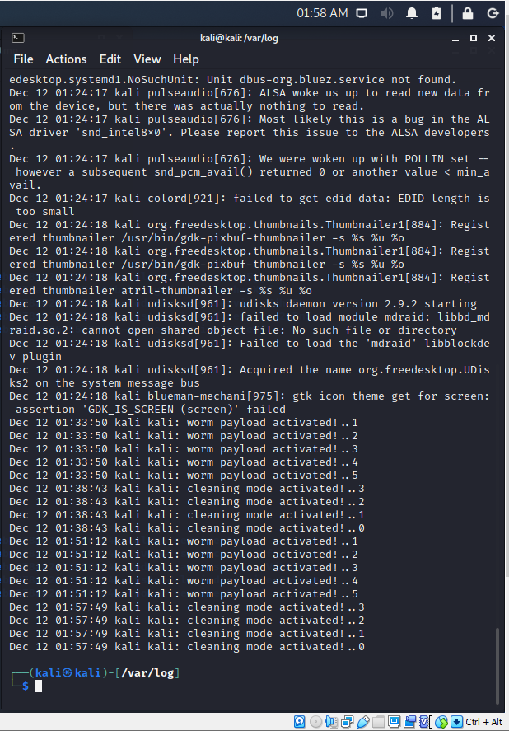

**A victim VM after a series of infections and disinfections**

Starting in kali folder:

**cd** ../../tmp

**ls** **-lsa**

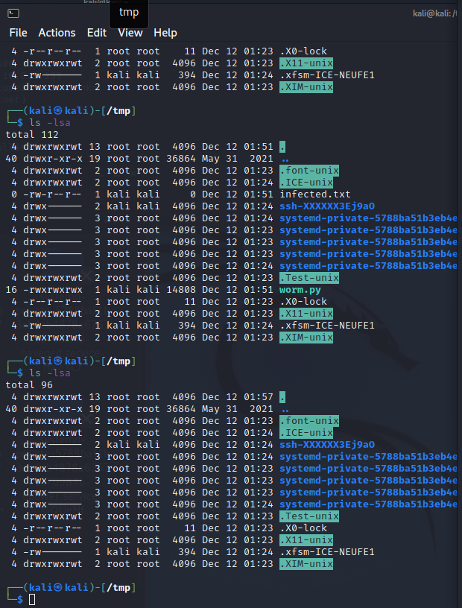

**/tmp folder contents after infection (top) and after disinfection (bottom)**

**Screenshot Library**

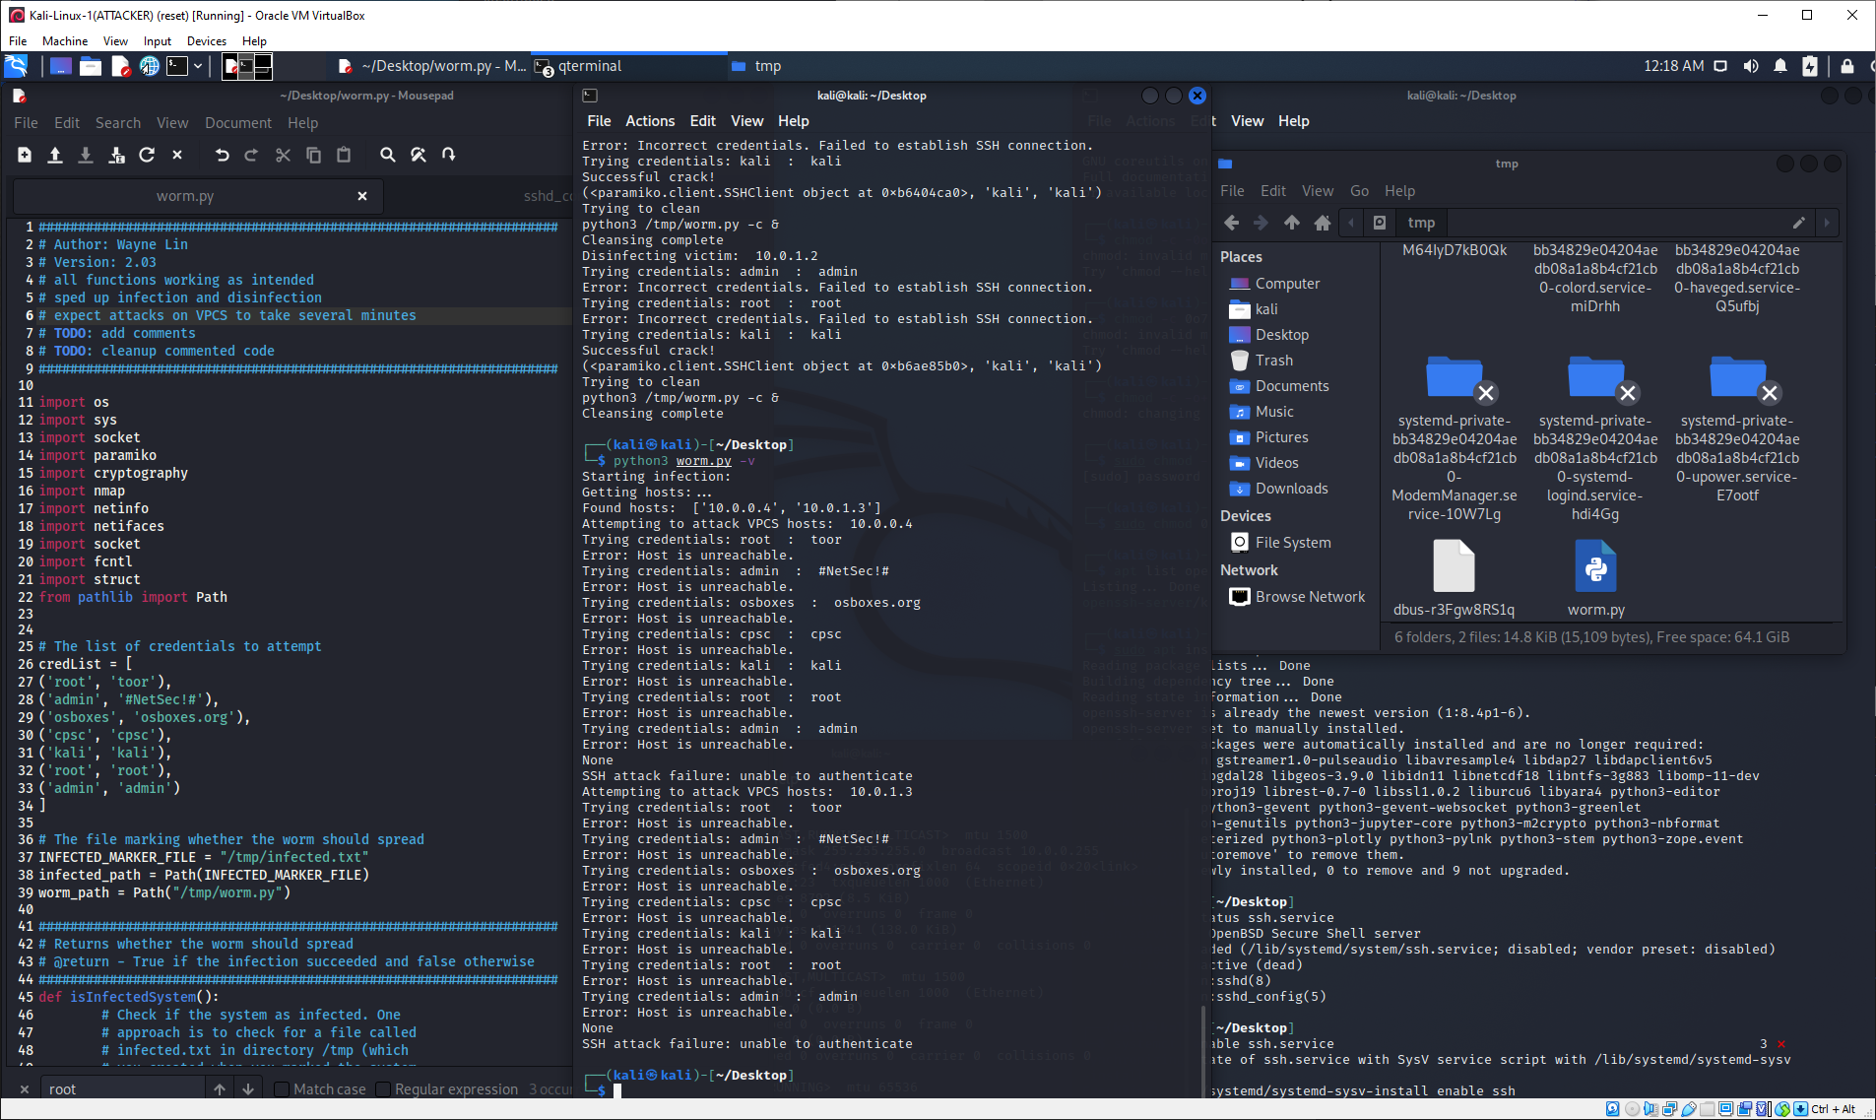

**Full VM view of failed attack on VPCS machines**

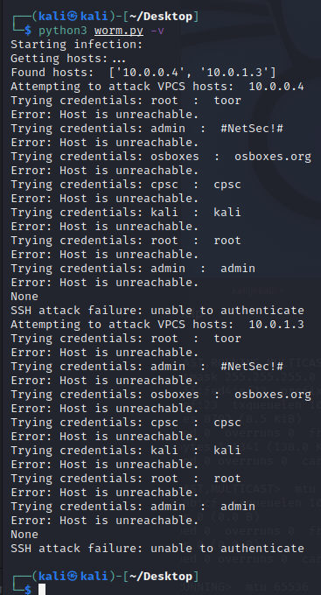

**Failed attack on VPCS machines (takes a very very very long time)**

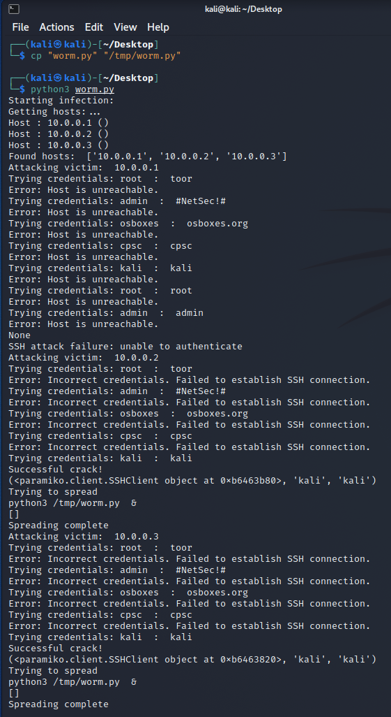

**Attacker VM command line output for default infection**

**Includes a failed router attack on 10.0.0.1**

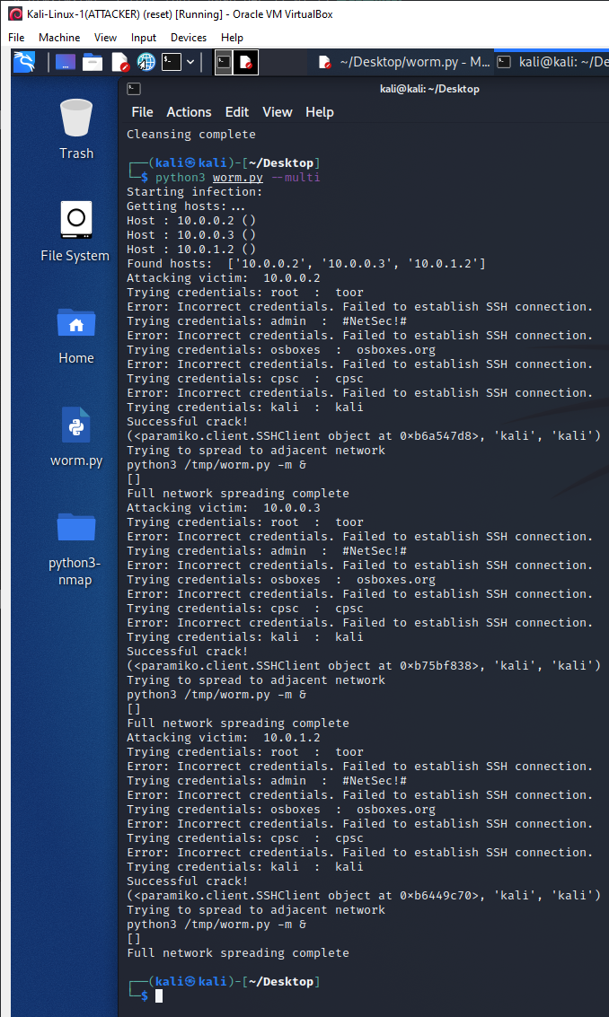

**Attacker VM command line output for multi-network infection (--multi)**

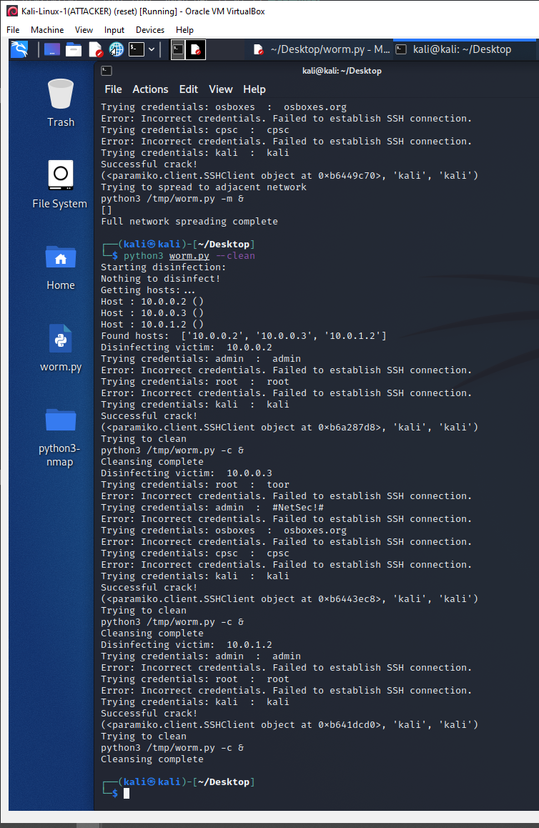

**“Attacker” VM command line output for multi-network disinfection (--clean)**

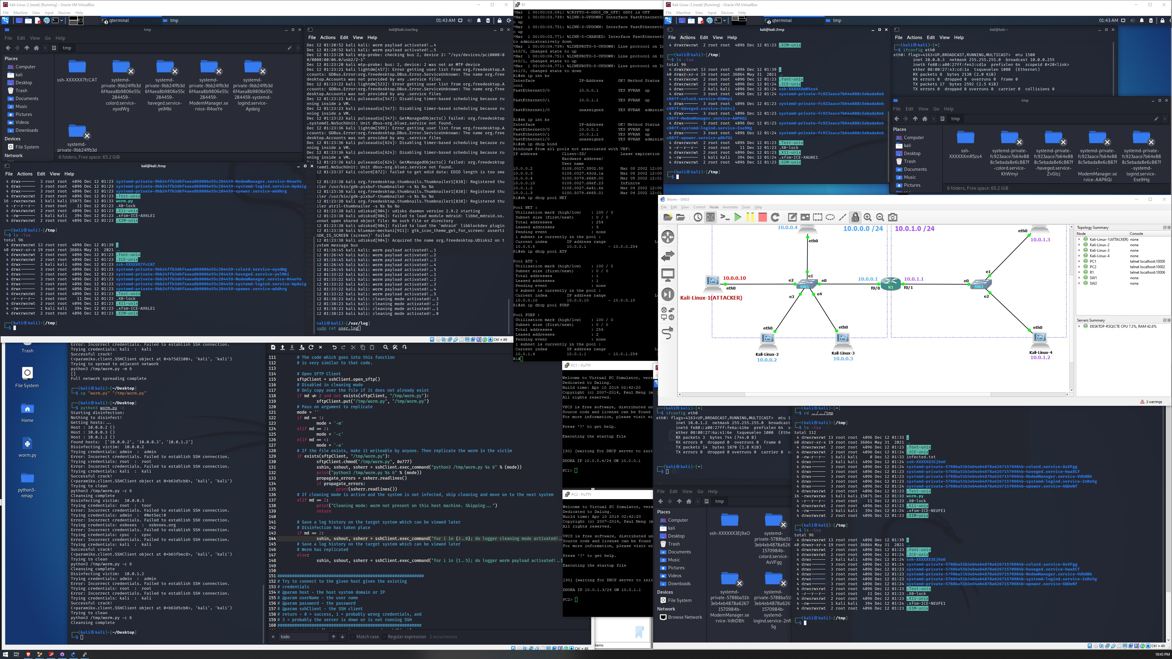

**GNS3 Environment after successfully cleaning all Kali VMs (-c)**

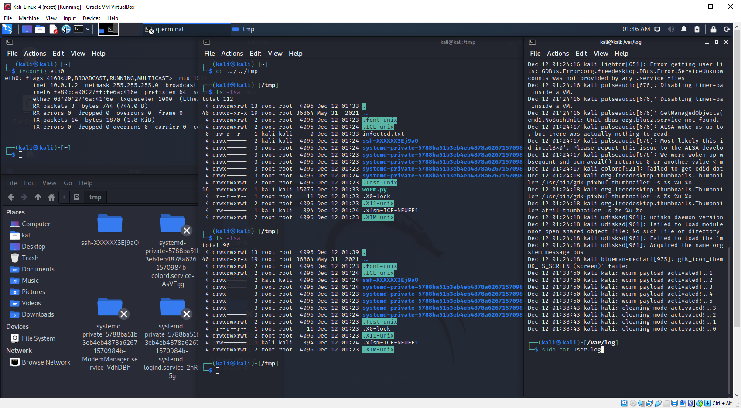

**Kali-Linux-4 on adjacent network after a successful disinfection (-c)**

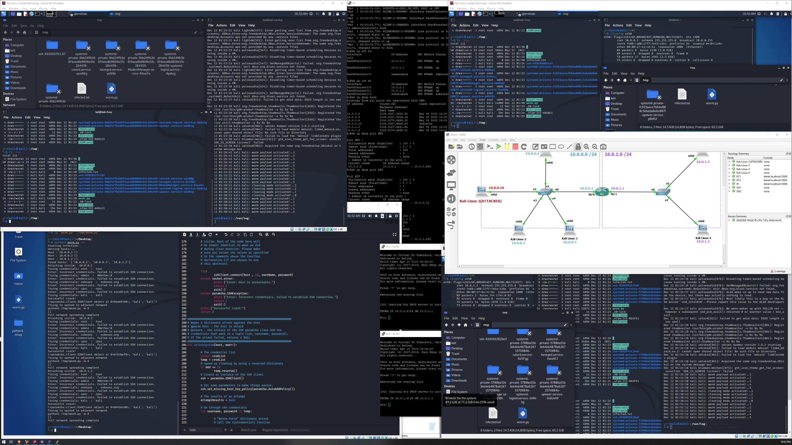

**GNS3 Environment after a multi-network (re)infection (-m)**

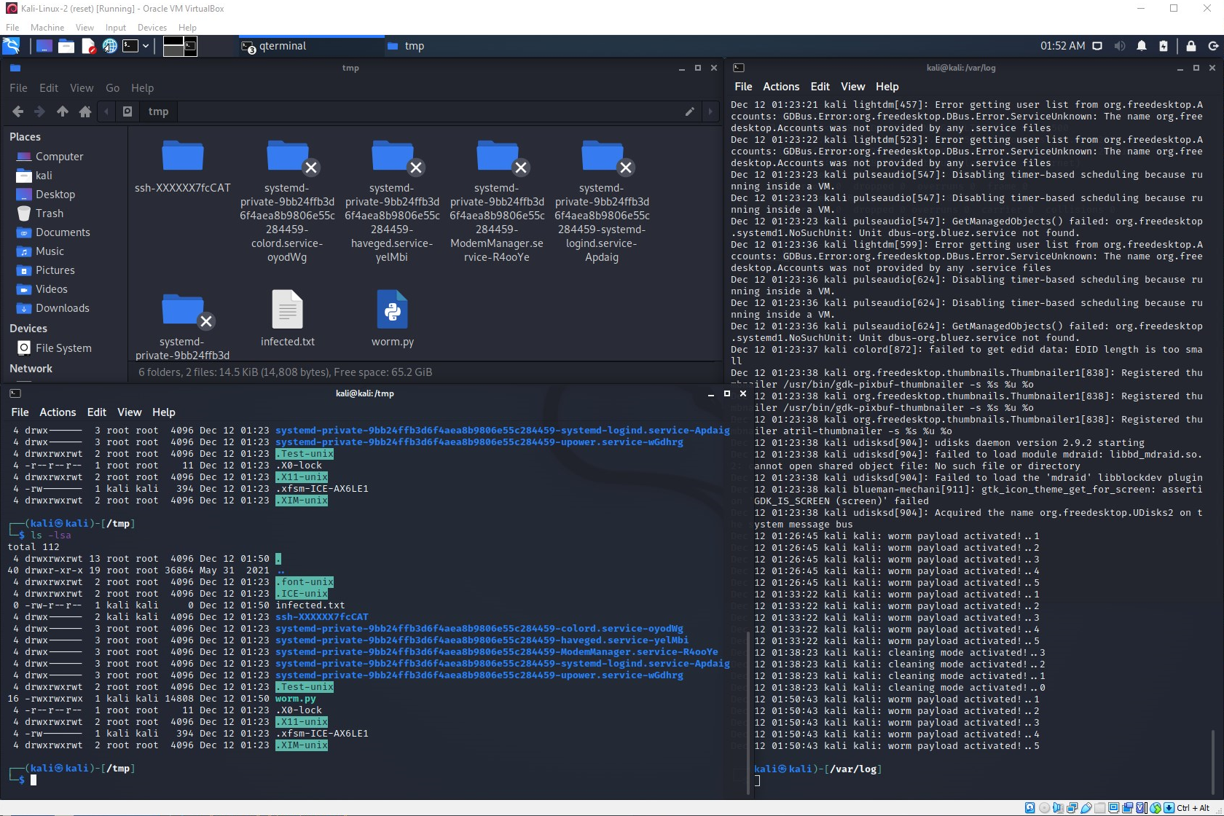

**Kali-Linux-2 gets infected by a multi-network attack (-m)**

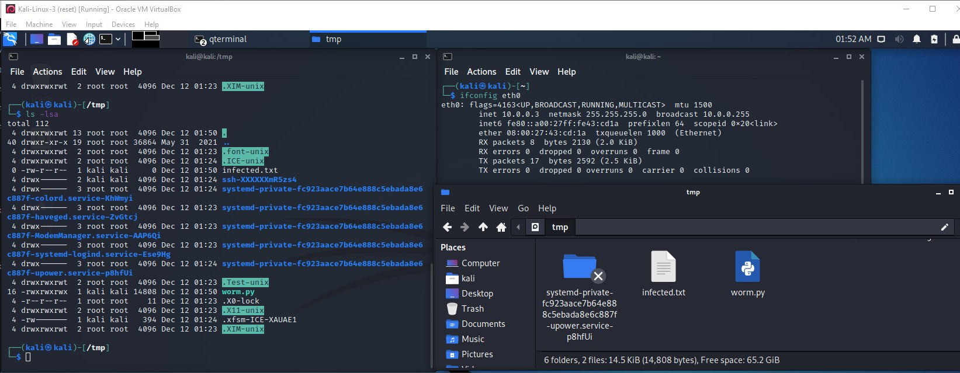

**Kali-Linux-3 gets infected by a multi-network attack (-m)**

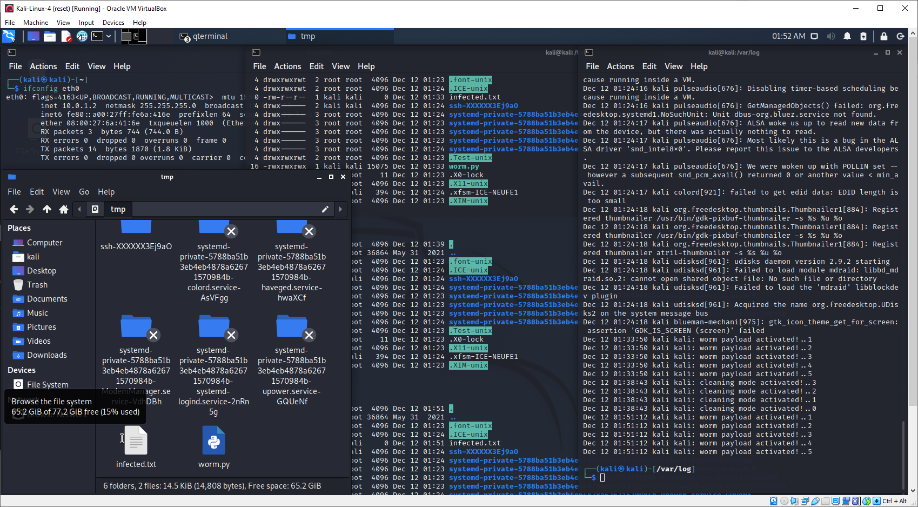

**Kali-Linux-4 on the adjacent network is also successfully infected (-m)**

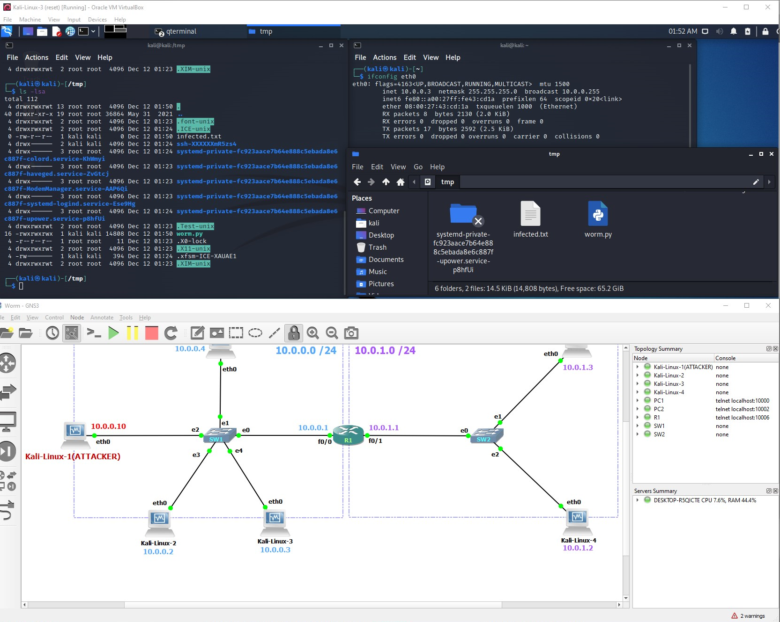

**Close-up of GNS3 Environment Running**

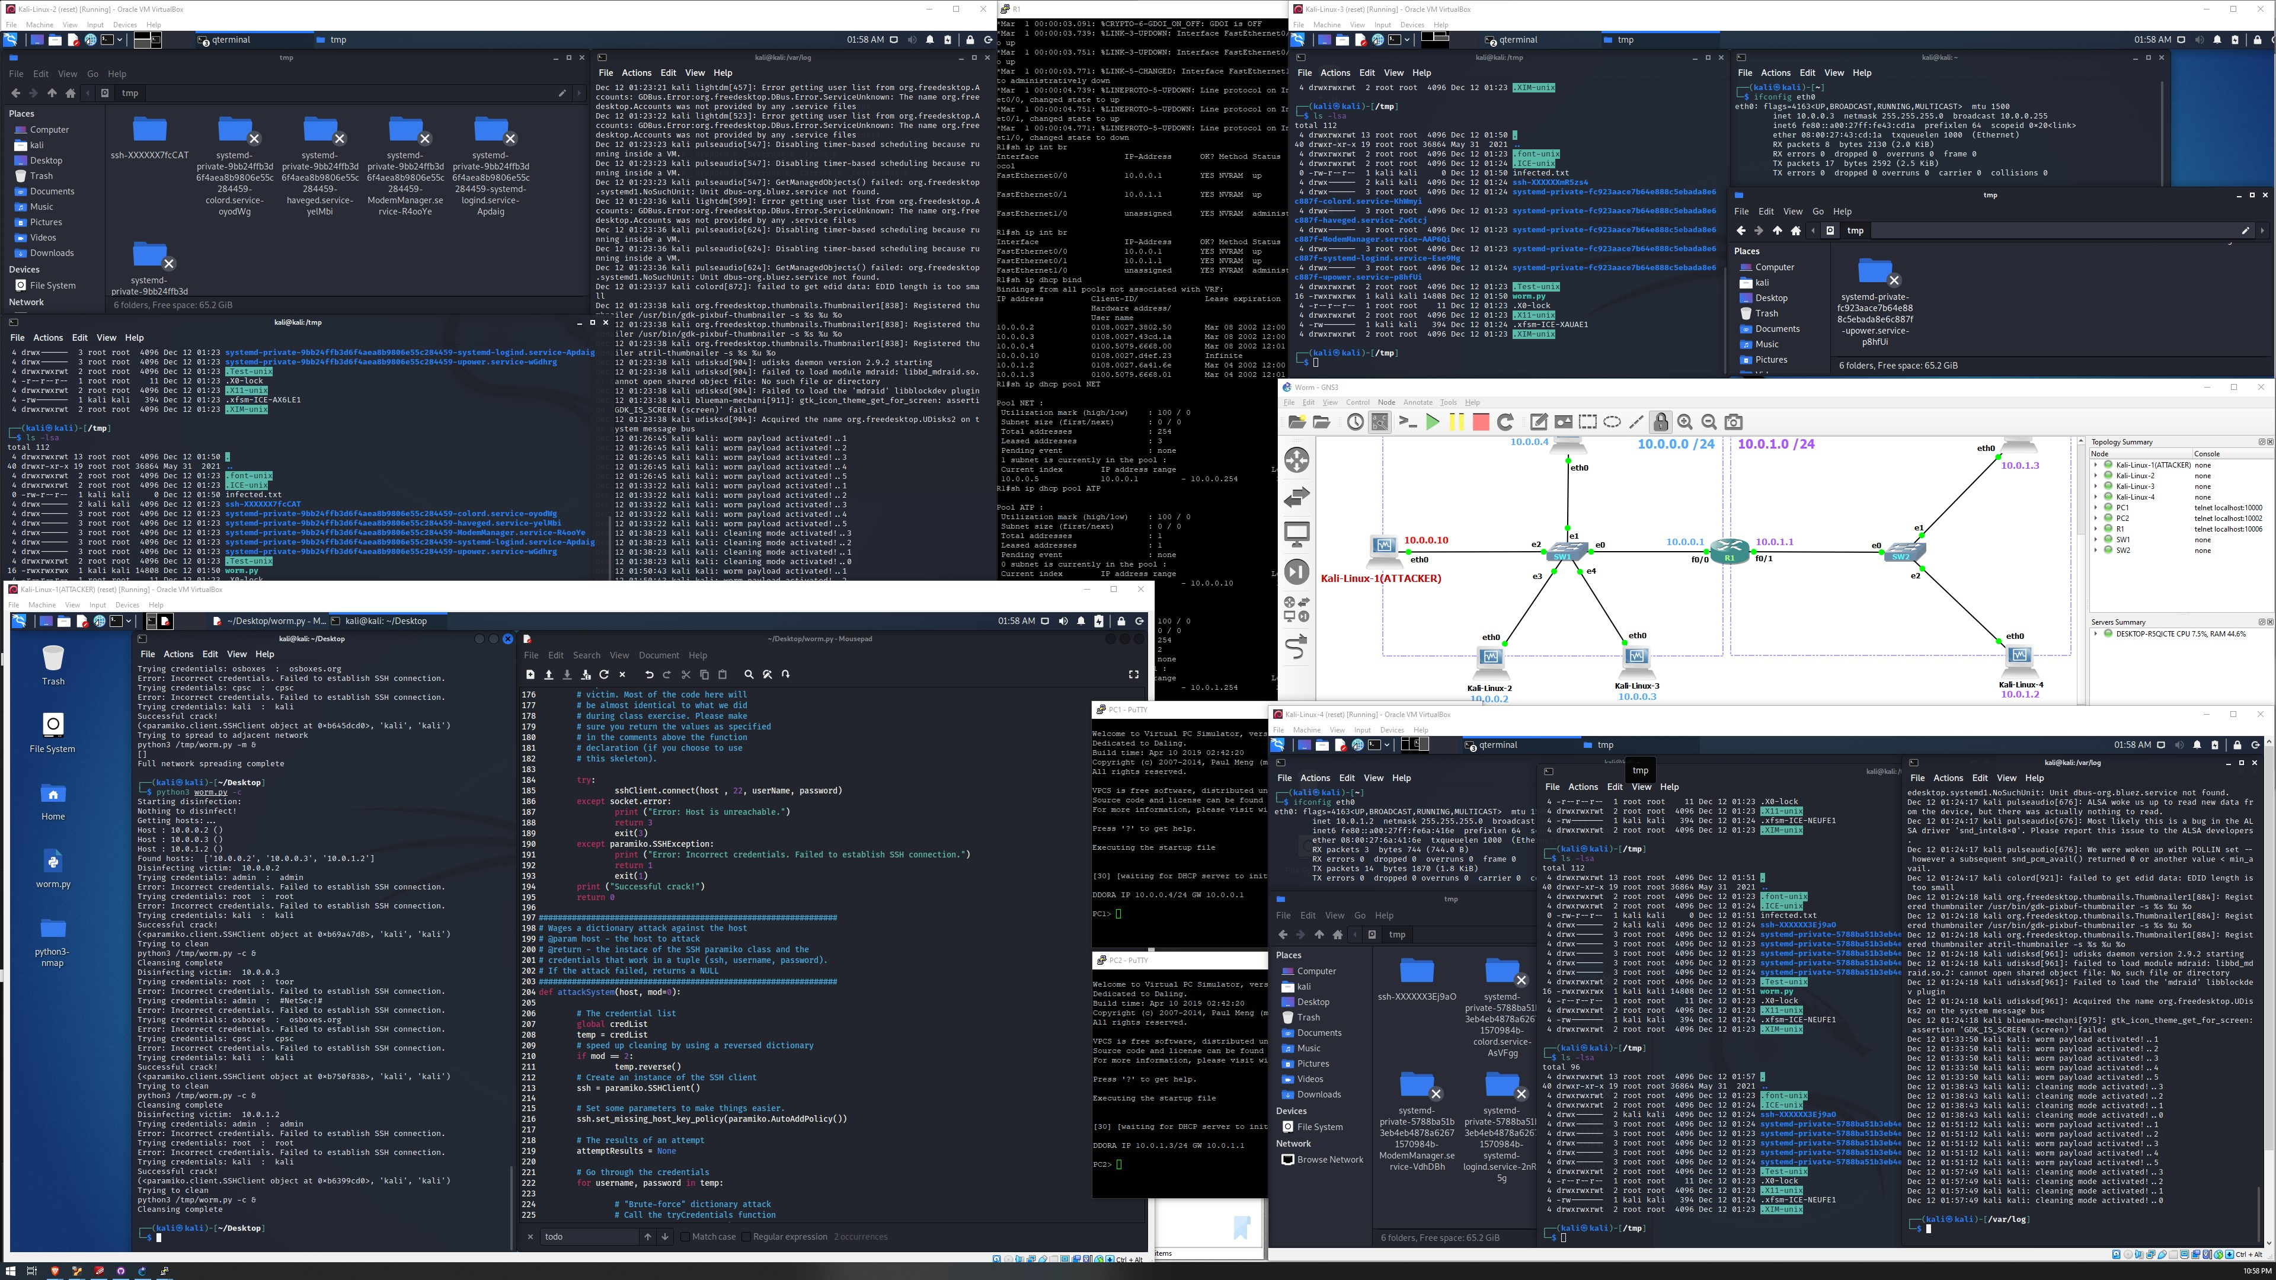

**GNS3 Environment after successfully disinfecting all Kali VMs again (-c)**

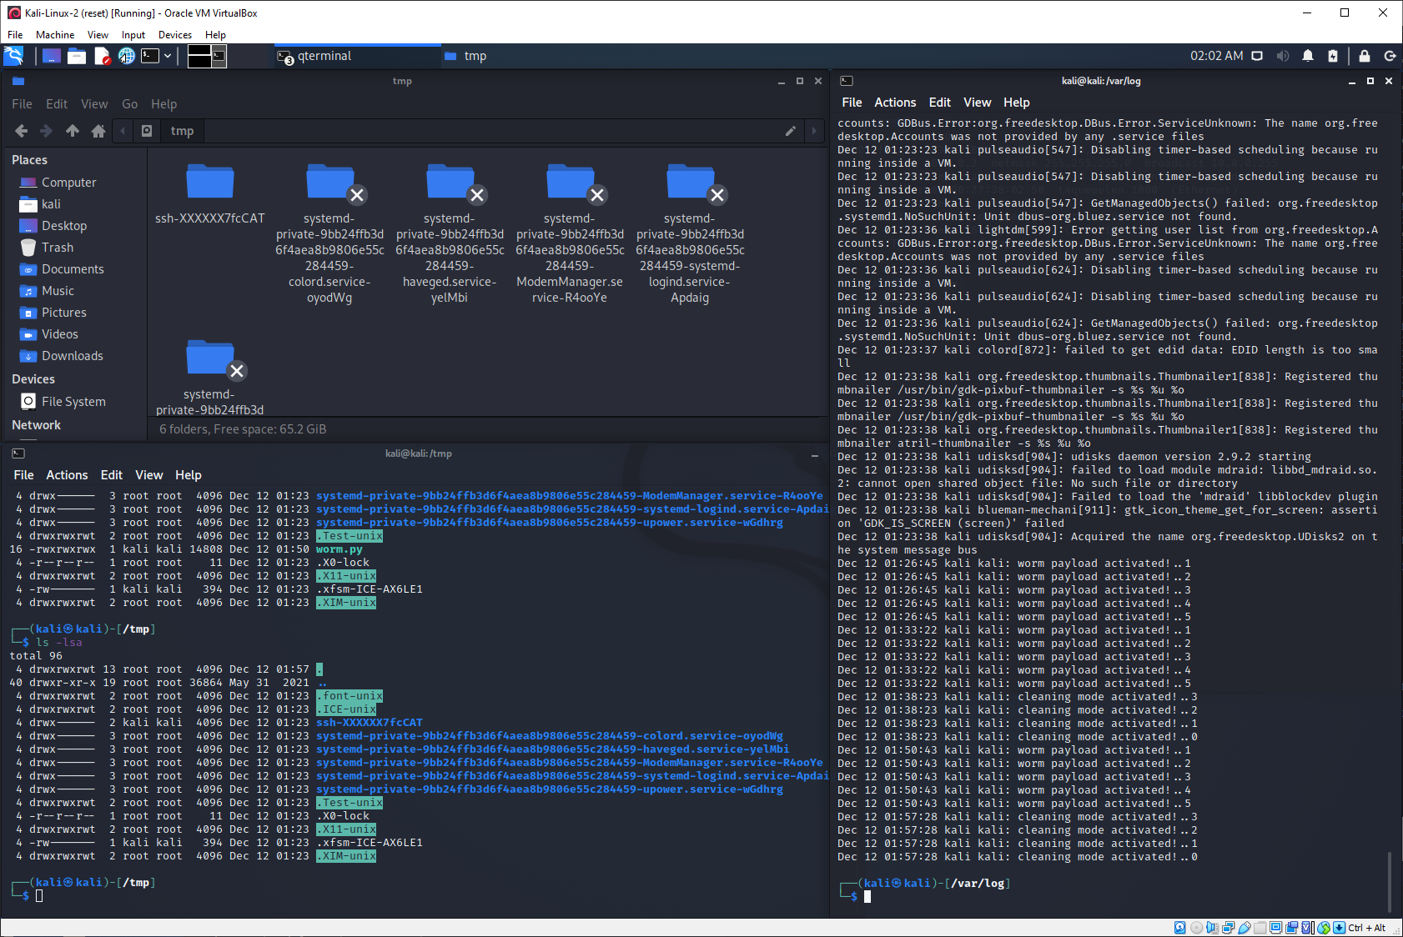

**Kali-2 after successful disinfection (-c)**

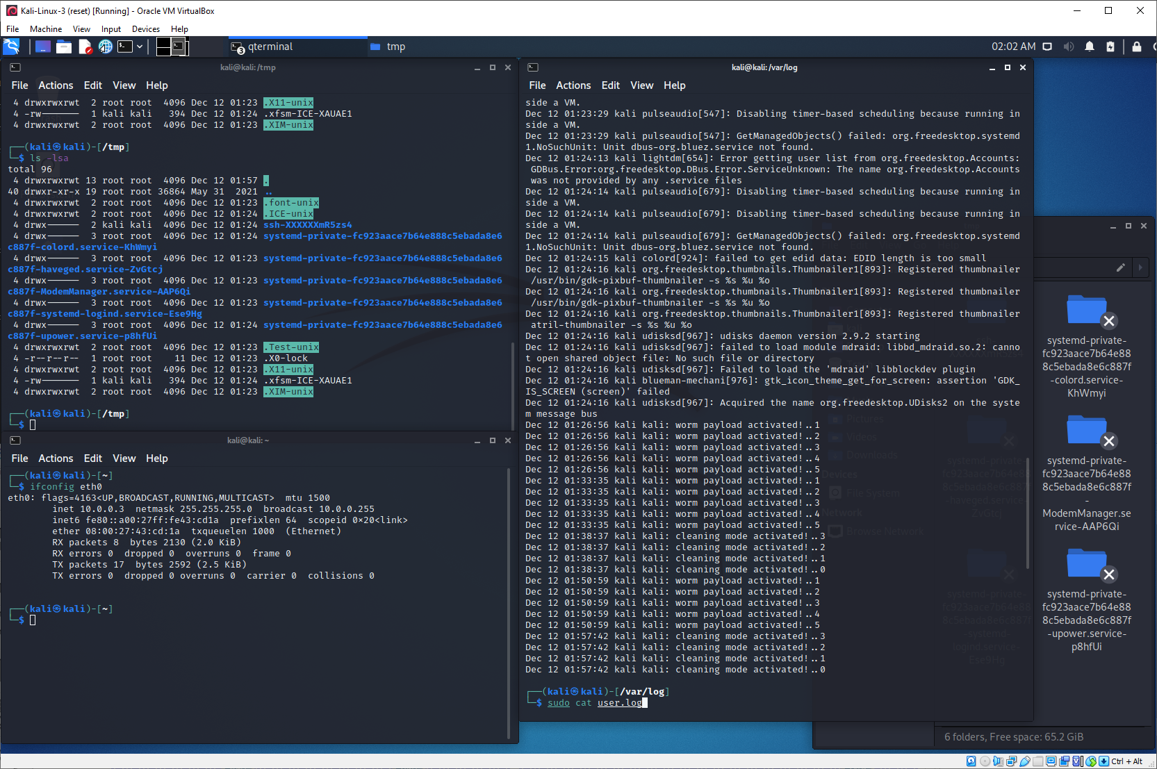

**Kali-3 after successful disinfection (-c)**

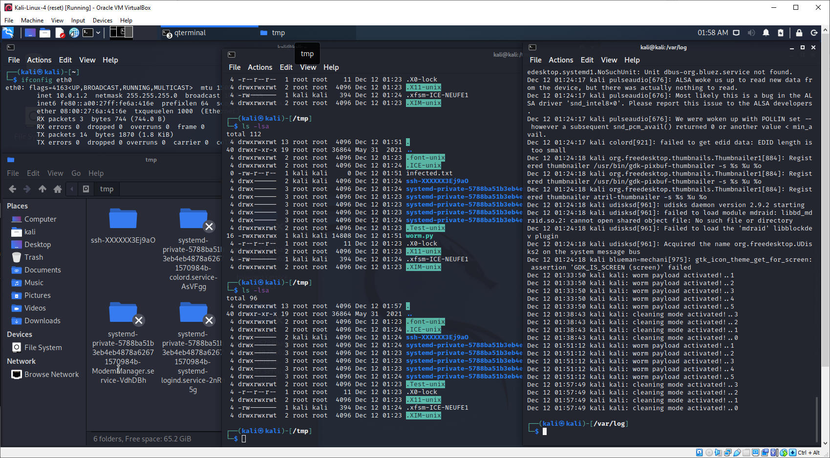

**Kali-4 after successful disinfection (-c)**

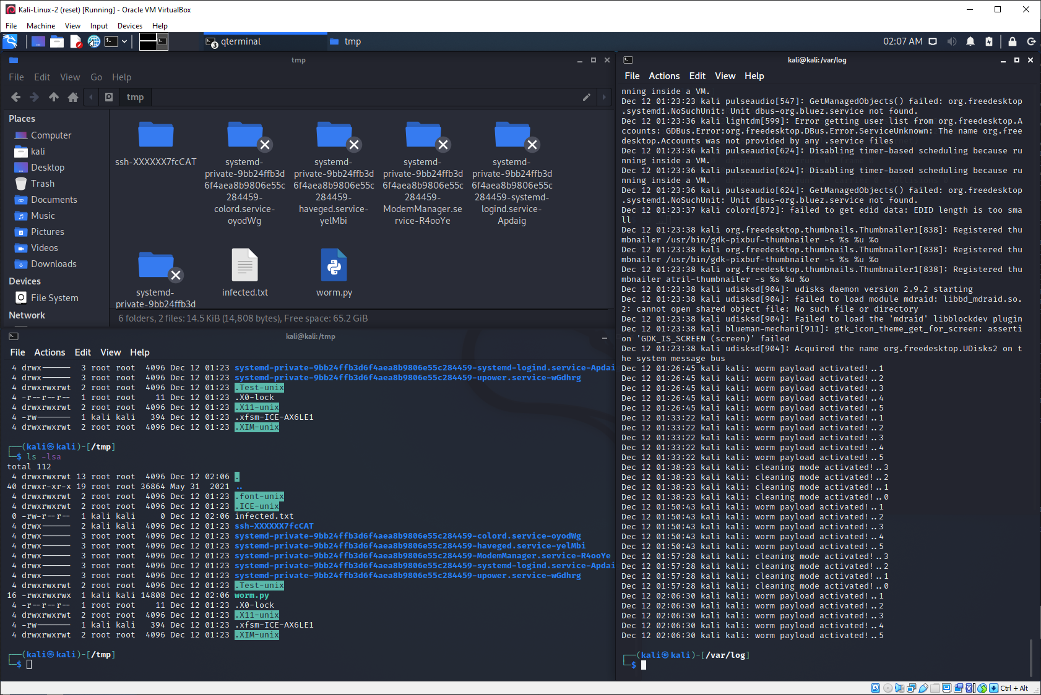

**Kali-2 after getting infected (no parameter)**

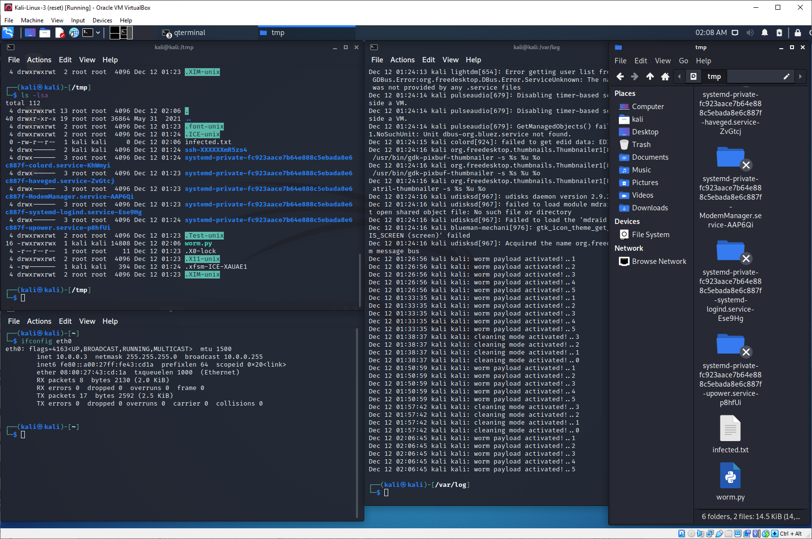

**Kali-3 after getting infected (no parameter)**